PROJECT: News Website

**Student Name:** Amna Mohammed AL Mazrou’i

**Student ID:** 232034

**Student Name:** Wafaa Adil AL Ghefeili

**Student ID:** 232605

**Student Name:** Amal Jasim Aljadidi

**Student ID:** 233130

**Student Name:** Hawraa khalifa Al busaidi

**Student ID:** 232103

**Course Coordinator:** Dr. Furqan Alam

**Course Code:** COMP1114

**Date of Submission:** 3/11____________________________

**The website's name is "Hawa," and it focuses on general news, targeting all age groups, including youth, children, and seniors.  
It features pages covering topics such as sport news, Tech news, national news, weather news, and international news.  
We talked in:  
  
  
 Sport news:  
1. Championship finals  
2. Player transfers  
3. Training updates  
  
Tech news:  
1. Ai innovation   
2. Gadget reviews   
3. Cypersecurity trends  
  
National news:  
1. Election updates  
2. Infrastructure projects  
3. Health campaigns  
  
International news:  
1. Global summit 2024  
2. Economic trends  
3. Space exploration**

**CSS CODE:**

body {

font-family: 'Times New Roman';

margin: 0;

padding: 0;

background-color: #f4e1c1;

color: #333;

}

header {

background-color: #003366;

color: white;

padding: 20px 0;

text-align: center;

}

header h1 {

margin: 0;

}

nav ul {

list-style: none;

padding: 0;

text-align: center;

}

nav ul li {

display: inline;

margin-right: 20px;

}

nav ul li a {

color: white;

text-decoration: none;

font-weight: bold;

text-transform: uppercase;

}

nav ul li a:hover {

color: #b28572;

}

main {

padding: 40px 20px;

}

.welcome-section {

text-align: center;

}

.welcome-section h2 {

font-size: 36px;

color: #5a3d31;

}

.welcome-section p {

font-size: 18px;

color: #555;

}

.featured-news {

margin-top: 40px;

}

.featured-news h2 {

text-align: center;

font-size: 30px;

color: #5a3d31;

}

.news-grid {

display: grid;

grid-template-columns: repeat(3, 1fr);

gap: 20px;

margin-top: 20px;

}

.news-item {

background-color: #fff;

padding: 20px;

border-radius: 8px;

box-shadow: 0 4px 8px rgba(0, 0, 0, 0.1);

}

.news-item img {

width: 420px;

height: 220px;

border-radius: 8px;

}

.news-item h3 {

font-size: 22px;

color: #5a3d31;

margin: 10px 0;

}

.news-item p {

font-size: 16px;

color: #555;

}

.news-item .btn {

display: inline-block;

background-color: #5a3d31;

color: white;

padding: 10px 20px;

text-decoration: none;

font-weight: bold;

margin-top: 10px;

border-radius: 5px;

}

.news-item .btn:hover {

background-color: #3c2a20;

}

footer {

background-color: #003366;

color: white;

text-align: center;

padding: 10px 0;

position: relative;

bottom: 0;

width: 100%;

}

**Home Page:  
-HTML code:**

<!DOCTYPE html>

<html lang="en">

<head>

<meta charset="UTF-8">

<meta name="viewport" content="width=device-width, initial-scale=1.0">

<title>Home Page</title>

<link rel="stylesheet" type="text/css" href="style.css">

</head>

<body>

<header>

<div class="header-container">

<img src="hwa.png" alt="Student News"

style="border-radius: 50%; box-shadow: 0px 6px 10px 2px rgba(0, 0, 0, 0.4);">

<br>

<br>

<nav>

<ul class="nav-links">

<li><a href="international.html">International News</a></li>

<li><a href="national.html">National News</a></li>

<li><a href="sports.html">Sports News</a></li>

<li><a href="tech.html">Tech News</a></li>

<li><a href="weather.html">Weather News</a></li>

<li><a href="contact.html">Contact Us</a></li>

</ul>

</nav>

</div>

</header>

<main>

<section class="welcome-section">

<h2>Welcome to the Student News Portal</h2>

<p>Explore the latest news across various categories including International, National, Sports, Technology, and Weather.</p>

</section>

<section class="featured-news">

<h2>Featured News</h2>

<div class="news-grid">

<div class="news-item">

<img src="international.png" alt="International News">

<h3>International News Highlight</h3>

<p>covers significant global events, including politics, economy, science, culture, and humanitarian issues. It keeps people informed about worldwide developments, promotes cultural awareness, and highlights issues like climate change, conflicts, and breakthroughs in technology. Reliable sources like BBC, CNN, and Reuters provide real-time updates, helping individuals understand global affairs and their potential impact.</p>

<a href="international.html" class="btn">Read More</a>

</div>

<div class="news-item">

<img src="sports.png" alt="Sports News">

<h3>Sports News Highlight</h3>

<p>Sports news highlights developments in training by the coach and also covers areas such as tournament finals, player transfers and training updates and keeps players and coaches updated on match plans.</p>

<a href="sports.html" class="btn">Read More</a>

</div>

<div class="news-item">

<img src="tech.png" alt="Tech News">

<h3>Technology News Highlight</h3>

<p>Tech news highlights advancements in technology, covering areas like AI, gadgets, cybersecurity, green tech, and space exploration. It keeps individuals and businesses updated on trends, innovations, and industry shifts, offering insights into future technologies and their societal impact. Key sources include TechCrunch, The Verge, and Wired.</p>

<a href="tech.html" class="btn">Read More</a>

</div>

</div>

</section>

</main>

<footer>

<p>&copy; 2024 News Portal. All rights reserved.</p>

</footer>

</body>

</html>

**-HOME PAGE SCREENSHOTS:**

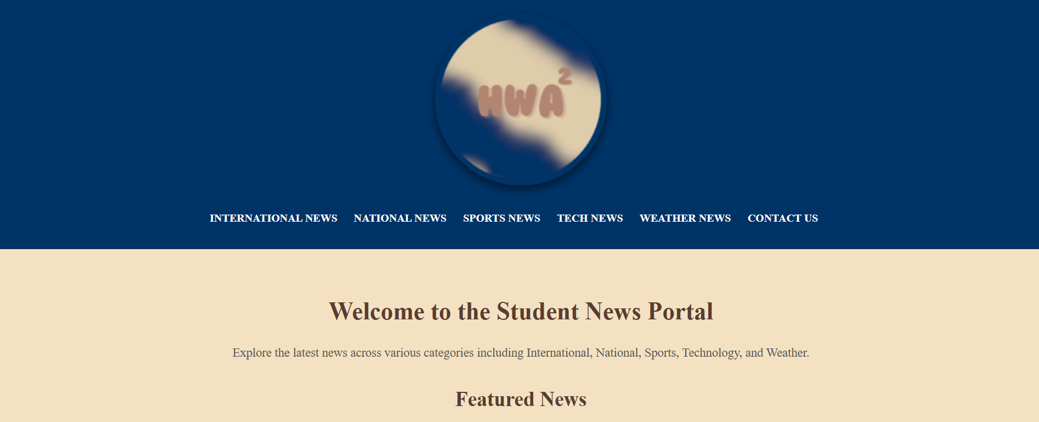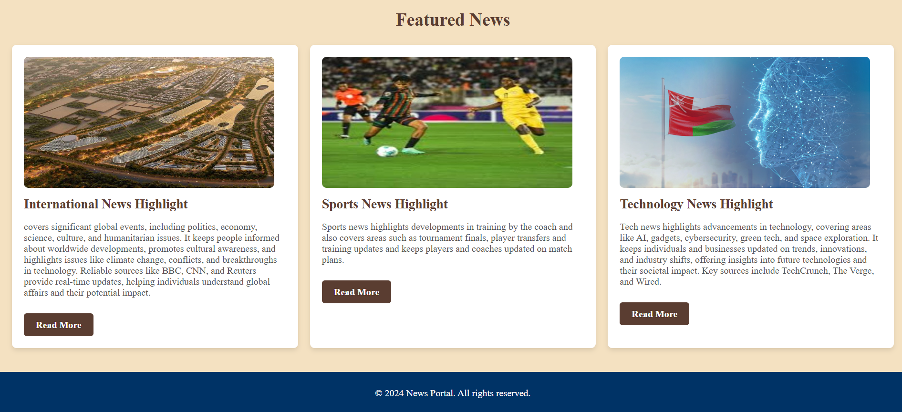

**International news page:**

**-HTML code:**

<!DOCTYPE html>

<html lang="en">

<head>

<meta charset="UTF-8">

<meta name="viewport" content="width=device-width, initial-scale=1.0">

<title>International News</title>

<link rel="stylesheet" type="text/css" href="style.css">

</head>

<body>

<header>

<div class="header-container">

<img src="hwa.png" alt="Student News"

style="border-radius: 50%; box-shadow: 0px 6px 10px 2px rgba(0, 0, 0, 0.4);">

<br>

<br>

<h1>International News</h1>

<nav>

<ul class="nav-links">

<li><a href="index.html">Home</a></li>

<li><a href="national.html">National News</a></li>

<li><a href="sports.html">Sports News</a></li>

<li><a href="tech.html">Tech News</a></li>

<li><a href="weather.html">Weather News</a></li>

<li><a href="contact.html">Contact Us</a></li>

</ul>

</nav>

</div>

</header>

<main>

<section class="news-section">

<h2>Latest International News</h2>

<div class="news-grid">

<div class="news-item">

<img src="news1.png" alt="News 1">

<h3>Oman Offers Free Visas for Iraqi Fans Ahead of World Cup Qualifier</h3>

<p>The Omani Embassy in Baghdad announced free entry visas for Iraqi football fans attending the 2026 World Cup qualifier match between Iraq and Oman in Muscat. The game will take place on November 19, 2024, at the Sultan Qaboos Complex Stadium. Fans can apply for the "Oman Ball Federation Visa" via the Royal Oman Police website from November 11 to 18. The visa is valid for seven days from entry and is exclusively for this event. This initiative underscores Oman’s support for international sports and its hospitality toward neighboring nations.</p>

</div>

<div class="news-item">

<img src="news2.png" alt="News 2">

<h3>World Bank: Oman’s Economic Outlook Positive for 2024</h3>

<p>

The World Bank forecasts Oman’s economy to grow by 1.5% in 2024, driven by increased gas production and economic diversification efforts. Key initiatives include enhancing the business environment, supporting SMEs, and advancing renewable energy investments, such as green hydrogen. Inflation is expected to stabilize at 2% over the medium term.

In the GCC region, growth is projected at 2.8% in 2024 and 4.7% in 2025, supported by a recovery in oil production and robust non-oil sector expansion. Despite diversification efforts, hydrocarbons will remain vital to fiscal stability, with the GCC fiscal surplus narrowing to 0.1% of GDP in 2024.

The report emphasizes improving education quality as essential for long-term growth, urging investments in foundational skills, teaching practices, and data-driven education policies to enhance human capital competitiveness globally.

</p>

</div>

<div class="news-item">

<img src="news3.png" alt="News 3">

<h3>Oman Reaching the Stars: The Aman Mission</h3>

<p>Oman's Aman mission marks its first space venture, laying the groundwork for the nation's broader space program under the Ministry of Transport, Communications, and Information Technology. The mission aims to inspire future space explorers and innovators, foster national talent, and drive Oman's transformation into a space-focused economy. The Aman satellite provides critical data for sectors like agriculture, energy, security, and environmental monitoring, fostering innovation and development. Key benefits include monitoring oil and gas fields, tracking crop health, predicting natural disasters, monitoring maritime activities, identifying optimal energy sites, promoting urban development, providing early warnings for risks, and enhancing security.</p>

</div>

</div>

</section>

</main>

<footer>

<p>&copy; 2024 News Portal. All rights reserved.</p>

</footer>

</body>

</html>

**-INTERNATIONAL NEWS PAGE SCREENSHOTS:**

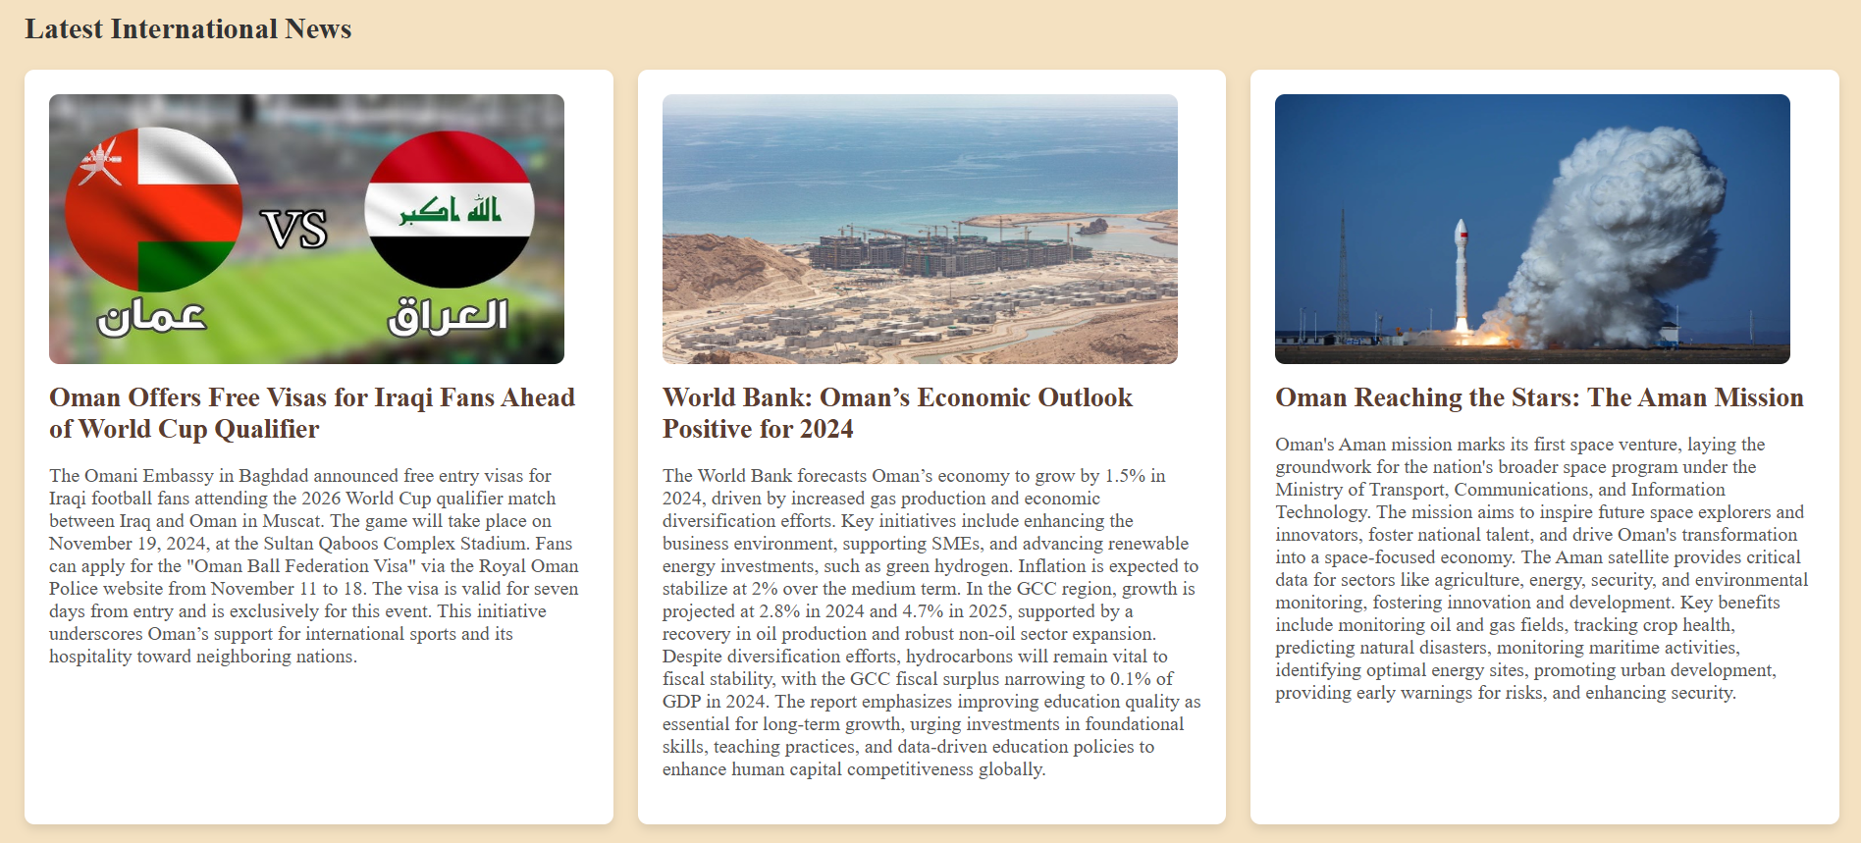

**National news page:**

**-HTML code:**

<!DOCTYPE html>

<html lang="en">

<head>

<meta charset="UTF-8">

<meta name="viewport" content="width=device-width, initial-scale=1.0">

<title>National News</title>

<link rel="stylesheet" type="text/css" href="style.css">

</head>

<body>

<header>

<div class="header-container">

<img src="hwa.png" alt="Student News"

style="border-radius: 50%; box-shadow: 0px 6px 10px 2px rgba(0, 0, 0, 0.4);">

<br>

<br>

<h1>National News</h1>

<nav>

<ul class="nav-links">

<li><a href="index.html">Home</a></li>

<li><a href="international.html">International News</a></li>

<li><a href="sports.html">Sports News</a></li>

<li><a href="tech.html">Tech News</a></li>

<li><a href="weather.html">Weather News</a></li>

<li><a href="contact.html">Contact Us</a></li>

</ul>

</nav>

</div>

</header>

<main>

<section class="news-section">

<h2>Latest National News</h2>

<div class="news-grid">

<div class="news-item">

<img src="national1.png" alt="News 1">

<h3>Election Updates</h3>

<p>Majlis A'shura, a financially and administratively independent institution, is the lower house of the Oman Council, representing different Wilayats and serving the nation. Members are elected by secret ballot, with membership terms of four Georgian years. The Sultanate is preparing for the tenth session of the Shura Council on October 29, with the Media Committee for the Shura Council Elections discussing preparations for media coverage and responsibilities. The committee's meeting aimed to ensure compliance with the Law for the Elections of Members of the Shura Council.</p>

</div>

<div class="news-item">

<img src="national2.png" alt="News 2">

<h3>Infrastructure Projects</h3>

<p>The Sultanate of Oman's infrastructure is crucial for economic growth and sustainability. The government has invested heavily in infrastructure projects, including expansion, modernization, and the use of advanced technologies. This has resulted in an integrated network of roads, world-class ports, modern educational and health institutions, and advanced entertainment and commercial facilities. These infrastructure sectors significantly impact the local economy, quality of life, and attract foreign investments. Key sectors include roads, transportation, ports, educational institutions, health institutions, recreational facilities, commercial facilities, and main services.</p>

</div>

<div class="news-item">

<img src="national3.png" alt="News 3">

<h3>Health Campaigns</h3>

<p>Awareness campaigns are crucial for improving public health, reducing chronic disease incidence, and reducing healthcare costs. World Health Day, celebrated annually on April 7, is celebrated with the slogan "My Health, My Right." A campaign at Muscat Mall, attended by doctors from various programs, aims to spread health awareness, promote healthy behaviors, and emphasize the importance of early disease detection. It encourages community members to adopt healthy lifestyles and focuses on health factors for building healthy societies.</p>

</div>

</div>

</section>

</main>

<footer>

<p>&copy; 2024 News Portal. All rights reserved.</p>

</footer>

</body>

</html>

-**NATIONAL NEWS PAGE SCREENSHOTS:**

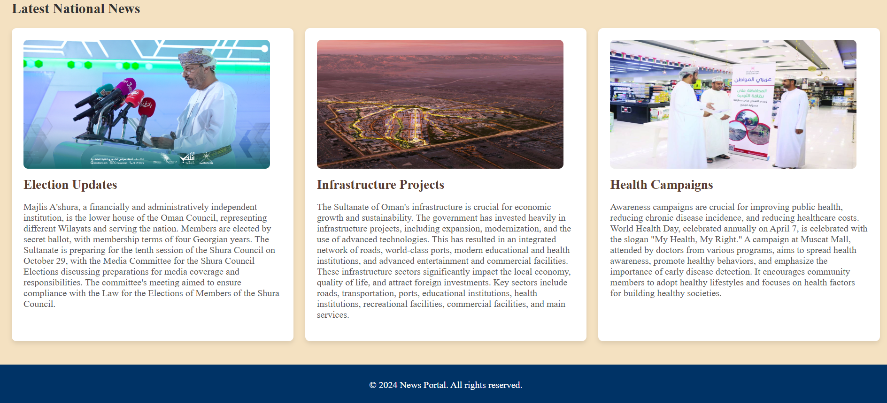

**Sports news page:**

**-HTML code:**

<!DOCTYPE html>

<html lang="en">

<head>

<meta charset="UTF-8">

<meta name="viewport" content="width=device-width, initial-scale=1.0">

<title>Sports News</title>

<link rel="stylesheet" type="text/css" href="style.css">

</head>

<body>

<header>

<div class="header-container">

<img src="hwa.png" alt="Student News"

style="border-radius: 50%; box-shadow: 0px 6px 10px 2px rgba(0, 0, 0, 0.4);">

<br>

<br>

<h1>Sports News</h1>

<nav>

<ul class="nav-links">

<li><a href="index.html">Home</a></li>

<li><a href="international.html">International News</a></li>

<li><a href="national.html">National News</a></li>

<li><a href="tech.html">Tech News</a></li>

<li><a href="weather.html">Weather News</a></li>

<li><a href="contact.html">Contact Us</a></li>

</ul>

</nav>

</div>

</header>

<main>

<section class="news-section">

<h2>Latest Sports News</h2>

<div class="news-grid">

<div class="news-item">

<img src="sports1.png" alt="News 1">

<h3>Championship Finals</h3>

<p>The 2023–24 AFC Champions League Final will be the final of the 2023–24 AFC Champions League, the 42nd edition of Asia's premier club football competition organised by the Asian Football Confederation (AFC), and the 21st edition of the AFC Champions League since its inception in 2003. The two-legged final will be contested by Yokohama F. Marinos of Japan and Al Ain of the United Arab Emirates. The winners will claim the final Asian berth at the 2025 FIFA Club World Cup in the United States. This will be Yokohama F. Marinos' second final after 1990, and Al Ain's fourth, most recently in 2016.</p>

</div>

<div class="news-item">

<img src="sports2.png" alt="News 2">

<h3>Player Transfers</h3>

<p>Marco Verratti may leave Inter in January due to his fluctuating performance in Qatar with Al-Arabi. Chelsea coach Enzo Maresca confirmed that his player Christopher Nkunku will not leave, and Manchester United may offer him a loan. Manchester City has identified Martin Zubimendi and Adam Wharton to replace Rodri in January, with Liverpool failing to convince Zubimendi to leave Spain last summer. Inter is considering a move for Jonathan David, and Juventus is marketing Douglas Luiz and Nicolo Fagiolo in the January transfer market.</p>

</div>

<div class="news-item">

<img src="sports3.png" alt="News 3">

<h3>Training Updates</h3>

<p>Marco Verratti may leave Inter due to his fluctuating performance in Qatar with Al-Arabi, with the club interested in the midfielder. Chelsea coach Enzo Maresca confirmed that his player Christopher Nkunku will not leave next January, and may move to Manchester United. Manchester City has identified Martin Zubimendi from Real Sociedad and Adam Wharton from Crystal Palace to replace Rodri in January. Liverpool failed to convince Zubimendi to leave Spain last summer, and Palace are expected to ask for around €70m to sell Wharton. Inter is considering a move for Jonathan David, with rumours intensifying after seeing his agent at the San Siro during Inter's match against Leipzig. Juventus are marketing Douglas Luiz and Nicolo Fagiolo in the January transfer market, as they are out of coach Thiago Motta's plans. Sports coaching and mentoring are interconnected processes that aim to enhance the performance, well-being, and personal growth of athletes, coaches, and organizations.</p>

</div>

</div>

</section>

</main>

<footer>

<p>&copy; 2024 News Portal. All rights reserved.</p>

</footer>

</body>

</html>

-**SPORTS NEWS PAGE SCREENSHOTS:**

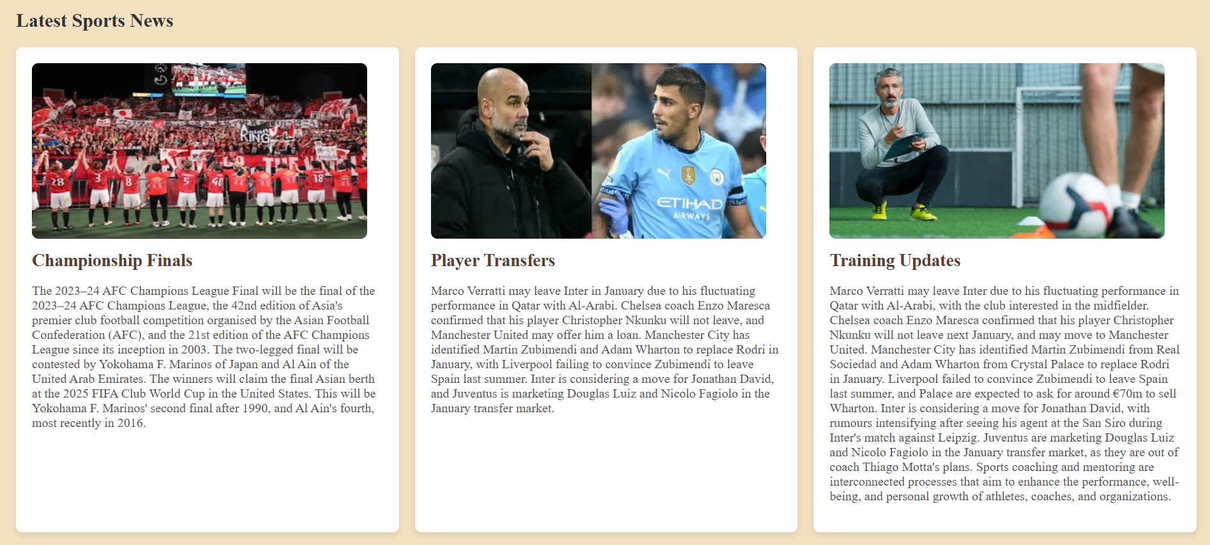

**Tech news page:**

**-HTML code:**

<!DOCTYPE html>

<html lang="en">

<head>

<meta charset="UTF-8">

<meta name="viewport" content="width=device-width, initial-scale=1.0">

<title>Tech News</title>

<link rel="stylesheet" type="text/css" href="style.css">

</head>

<body>

<header>

<div class="header-container">

<img src="hwa.png" alt="Student News"

style="border-radius: 50%; box-shadow: 0px 6px 10px 2px rgba(0, 0, 0, 0.4);">

<br>

<br>

<h1>Tech News</h1>

<nav>

<ul class="nav-links">

<li><a href="index.html">Home</a></li>

<li><a href="international.html">International News</a></li>

<li><a href="national.html">National News</a></li>

<li><a href="sports.html">Sports News</a></li>

<li><a href="weather.html">Weather News</a></li>

<li><a href="contact.html">Contact Us</a></li>

</ul>

</nav>

</div>

</header>

<main>

<section class="news-section">

<h2>Latest Tech News</h2>

<div class="news-grid">

<div class="news-item">

<iframe width="420" height="220" src="https://www.youtube.com/embed/QR6r-e8MyjA?si=j-rG8l3uVoTOssVB" title="YouTube video player" frameborder="0" allow="accelerometer; autoplay; clipboard-write; encrypted-media; gyroscope; picture-in-picture; web-share" referrerpolicy="strict-origin-when-cross-origin" allowfullscreen></iframe>

<h3>Oman Launches National AI and Advanced Digital Technologies Program</h3>

<p>

Oman has launched its National Program for Artificial Intelligence (AI) and Advanced Digital Technologies, led by H.E. Said bin Hamoud Al Maawali, Minister of Transport, Communications, and Information Technology (MTCIT). The initiative, part of Oman Vision 2040, aims to establish a robust digital economy that promotes sustainable development. The program consists of three pillars:

</p>

<p>

1. AI Integration: Enhancing quality and efficiency in economic and developmental sectors by applying AI.

</p>

<p>

2. Localization of AI: Strengthening public-private partnerships, developing local talent, and advancing AI-driven research.

</p>

<p>

3. Governance and Safety: Ensuring ethical use of AI through legislation, regulatory frameworks, and data protection.

</p>

<p>

The program aligns with Oman’s goal of being among the top 50 nations in the Government AI Readiness Index, emphasizing innovation and sustainability.

</p>

</div>

<div class="news-item">

<iframe width="420" height="220" src="https://www.youtube.com/embed/yx_hBOulyTk?si=aNjHS6WeWIRwS2Lv" title="YouTube video player" frameborder="0" allow="accelerometer; autoplay; clipboard-write; encrypted-media; gyroscope; picture-in-picture; web-share" referrerpolicy="strict-origin-when-cross-origin" allowfullscreen></iframe>

<h3>Gadget review in Oman:</h3>

<p>In Oman, gadget reviews focus on the latest consumer electronics like smartphones, laptops, wearables, and smart home devices. These reviews assess performance, design, features, and value, helping consumers make informed choices. Popular tech review sources in Oman include Muscat Daily, Times of Oman, and local tech blogs, offering insights into products like smartphones, gaming hardware, and smart home technology. These reviews play a key role in keeping Omani consumers updated on the latest tech trends. </p>

</div>

<div class="news-item">

<iframe width="420" height="220" src="https://www.youtube.com/embed/JXmqJ6sEl3U?si=yYGgeuhCY-BM5NDu" title="YouTube video player" frameborder="0" allow="accelerometer; autoplay; clipboard-write; encrypted-media; gyroscope; picture-in-picture; web-share" referrerpolicy="strict-origin-when-cross-origin" allowfullscreen></iframe>

<h3>Oman Cybersecurity Market Size & Share Analysis</h3>

<p>Oman’s Cybersecurity Market Report is Segmented by Offering (solutions, [application Security, Cloud Security, Consumer Security Software, Data Security, Identity and Access Management, Infrastructure Protection, Integrated Risk Management, Network Security Equipment, and Other Solutions], Services [professional Services and Managed Services]), Deployment (cloud and On-Premise), End-User Industry (IT and Telecom, BFSI, Retail and E-Commerce, Oil Gas and Energy, Manufacturing, Government and Defense, Other End-User Industries). The Market Sizes and Forecasts are Provided in Terms of Value (USD) for all the Above Segments.</p>

</div>

</div>

</section>

</main>

<footer>

<p>&copy; 2024 News Portal. All rights reserved.</p>

</footer>

</body>

</html>

-**TECH NEWS PAGE SCREENSHOTS:**

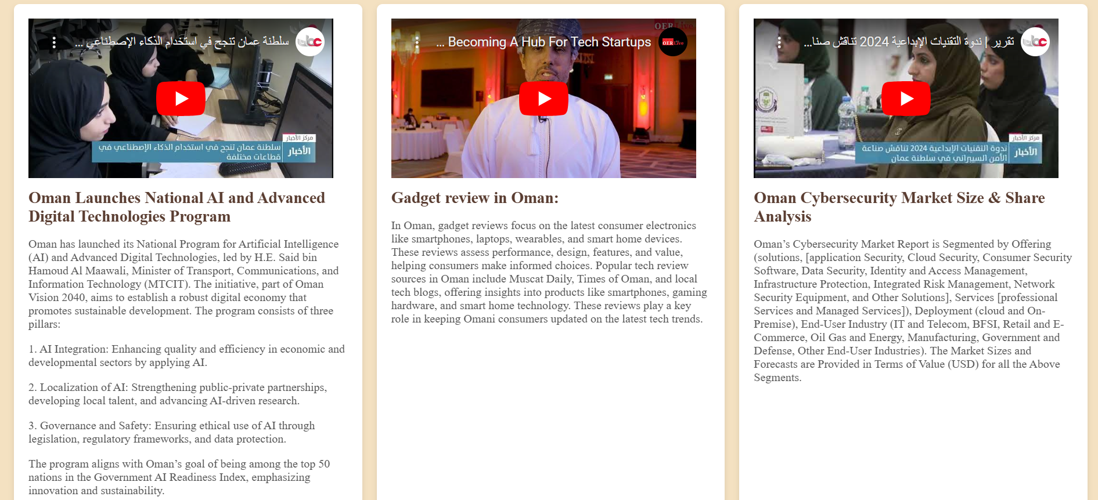

**Weather news page:**

**-HTML code:**

<!DOCTYPE html>

<html lang="en">

<head>

<meta charset="UTF-8">

<meta name="viewport" content="width=device-width, initial-scale=1.0">

<title>Weather News</title>

<link rel="stylesheet" type="text/css" href="style.css">

</head>

<body>

<header>

<div class="header-container">

<img src="hwa.png" alt="Student News"

style="border-radius: 50%; box-shadow: 0px 6px 10px 2px rgba(0, 0, 0, 0.4);">

<br>

<br>

<h1>Weather News</h1>

<nav>

<ul class="nav-links">

<li><a href="index.html">Home</a></li>

<li><a href="international.html">International News</a></li>

<li><a href="national.html">National News</a></li>

<li><a href="sports.html">Sports News</a></li>

<li><a href="tech.html">Tech News</a></li>

<li><a href="contact.html">Contact Us</a></li>

</ul>

</nav>

</div>

</header>

<main>

<section class="news-section">

<h2>Latest Weather Updates</h2>

<div class="news-grid">

<div class="news-item">

<iframe width="420" height="220" src="https://www.youtube.com/embed/HJ0rQeYxaQ0?si=B5_gsR7izm0vv1LC&amp;start=30" title="YouTube video player" frameborder="0" allow="accelerometer; autoplay; clipboard-write; encrypted-media; gyroscope; picture-in-picture; web-share" referrerpolicy="strict-origin-when-cross-origin" allowfullscreen></iframe>

<h3>Severe Weather Alerts</h3>

<p>

The Oman Meteorological Department of the Civil Aviation Authority has issued weather forecasts for the Sultanate of Oman within the country, indicating that there is a high probability of thunderstorms in many areas within the country, and cumulus clouds are expected to form and that rain will be accompanied by winds in many areas.

Apple has introduced several important features in the weather app, as the weather app can send a notification in the event of a severe weather alert near you, so you can get alerts for major rainstorms, floods, hurricanes, heat waves and tornadoes, according to MacRumors. You can turn on severe weather alerts for your current location and any location you have added to the weather app, and severe weather data is available for most countries in the world.

</p>

</div>

<div class="news-item">

<iframe width="420" height="220" src="https://www.youtube.com/embed/37bHnKsk2ko?si=xnSf1yEYww8TFymE" title="YouTube video player" frameborder="0" allow="accelerometer; autoplay; clipboard-write; encrypted-media; gyroscope; picture-in-picture; web-share" referrerpolicy="strict-origin-when-cross-origin" allowfullscreen></iframe>

<h3>Weekly Forecast</h3>

<p>

• How is the weather report submitted?

To request the emergency reports service, the following is required:

Submit an official letter to the name of the person requesting the report, and the satisfaction of that report.

Specify the elements included in the report.

Specify the place and time of the required report.

Specify the term of the repor

t (previous astronomical reports or future forecasts).

How do we know the weekly weather forecast?

You can see the next weather event in Google's live weather forecast. It displays hourly weather forecasts and any precipitation events expected later using data provided by weather.com.

.

</p>

</div>

<div class="news-item">

<iframe width="420" height="220" src="https://www.youtube.com/embed/hNHAumgGpEU?si=w9FEtSVykwo_xhgV" title="YouTube video player" frameborder="0" allow="accelerometer; autoplay; clipboard-write; encrypted-media; gyroscope; picture-in-picture; web-share" referrerpolicy="strict-origin-when-cross-origin" allowfullscreen></iframe>

<h3>Climate Change Impact</h3>

<p>

Climate change is a global or regional alteration caused by human activities, primarily greenhouse gas emissions, resulting in the "greenhouse effect" and affecting the environment, society, and economy. Oman has experienced significant financial losses from tropical storms, with Cyclone Gonu causing $4 billion in 2007 and Mekunu causing $1.5 billion in 2018. Al-Batinah North, Muscat, Sur, and Salalah are particularly vulnerable due to Oman's coastline and coastal areas.

</p>

</div>

</div>

</section>

</main>

<footer>

<p>&copy; 2024 News Portal. All rights reserved.</p>

</footer>

</body>

</html>

-**WEATHER NEWS PAGE SCREENSHOTS:**

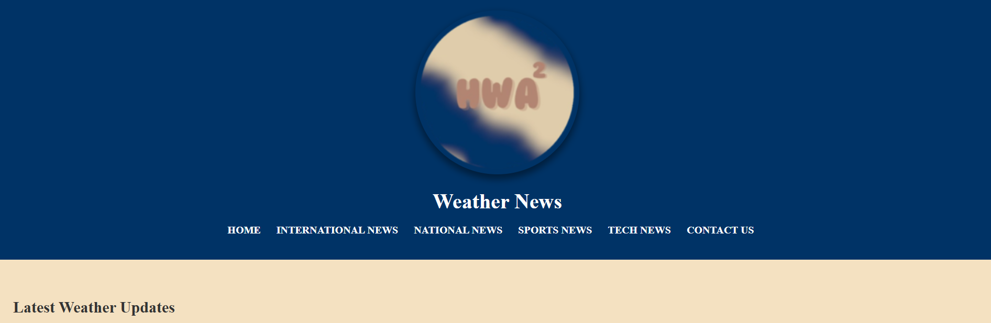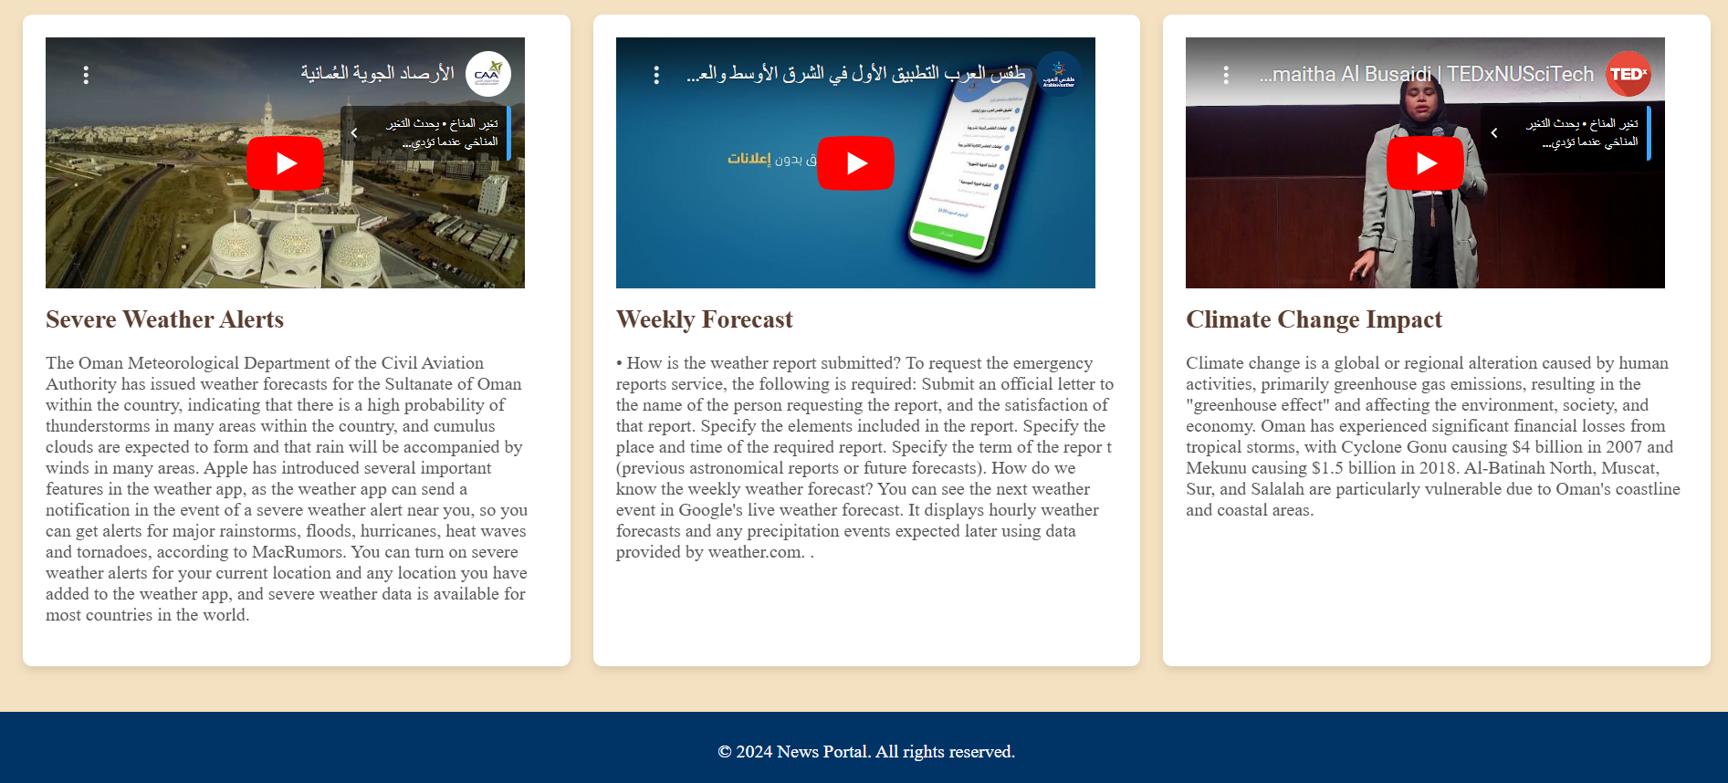

**Contact us page:**

**-HTML code:**

<!DOCTYPE html>

<html lang="en">

<head>

<meta charset="UTF-8">

<meta name="viewport" content="width=device-width, initial-scale=1.0">

<title>Contact Us</title>

<link rel="stylesheet" type="text/css" href="style.css">

</head>

<body>

<header>

<div class="header-container">

<img src="hwa.png" alt="Student News"

style="border-radius: 50%; box-shadow: 0px 6px 10px 2px rgba(0, 0, 0, 0.4);">

<br>

<br>

<h1>Contact Us</h1>

<nav>

<ul class="nav-links">

<li><a href="index.html">Home</a></li>

<li><a href="international.html">International News</a></li>

<li><a href="national.html">National News</a></li>

<li><a href="sports.html">Sports News</a></li>

<li><a href="tech.html">Tech News</a></li>

<li><a href="weather.html">Weather News</a></li>

</ul>

</nav>

</div>

</header>

<main>

<section class="contact-section">

<h2>We'd love to hear from you!</h2>

<form action="#" method="POST" class="contact-form">

<label for="name">Name:</label>

<input type="text" id="name" name="name" required>

<br>

<br>

<br>

<label for="email">Email:</label>

<input type="email" id="email" name="email" required>

<br>

<br>

<br>

<label for="message">Message:</label>

<textarea id="message" name="message" rows="5" required></textarea>

<br>

<br>

<br>

<button type="submit" class="submit-btn">Submit</button>

</form>

</section>

</main>

<footer>

<p>&copy; 2024 News Portal. All rights reserved.</p>

</footer>

</body>

</html>

-**CONTACT US PAGE SCREENSHOTS:**

